GALLERIA

**GALLARIA PAINTINGS**

Painting Website

E-PROJECT

|  |  |  |
| --- | --- | --- |
| Superviser |  | Sir Maaz Anis |
| Batch No |  | PR2-2023-02G |
| Serial NO. | **Enrollment**  **No.** | **Student Name** |
| 1. | Student1455043 | M. Sarmad Shakeel |
| 2. | Student1434970 | Unzila |
| 3. | Student1456863 | Daniyal |
| 4. | Student1445678 | Abdul Rehman |

**CERTIFICATE OF COMPLETION…………………………………………………..(3)**

**ACKNOWLEGEMENT …………………………………………………………………(4)**

**PROJECT SYNOPSIS……………………………………………………………………(5)**

**FUNCTIONAL REQUIRMENT…………………………………………………………...(6)**

**PROBLEM STATEMENT…………………………………………………………………………..(7)**

**HADWARE AND SOFTWARE REQUIRMENT…………………………………………………(7)**

**USER GUIDE……………………………………………………………………………………………(8)**

**HOME PAGE…………………………………………………………………………….(8)**

**ABOUT US…………………………………………………………………………………………………(9)**

**GALLERY……………………………………………………………………………………..(10)**

**CATEGORIES………………………………………………………………………………(11 to 13)**

**CONTACT………………………………………………………………………………….(13,14)**

**CERTIFICATE OF COMPLETION**

This is to certify that, Daniyal, M. Sarmad Shakeel, Unzila, Abdul Rehman

haveSuccessfully completed their CPISM Prime 2.0

Semester 1 E-Project

Submitted to: APTECH COMPUTER EDUCATION

ON

August 08, 2023

**ACKNOWLEGEMENT**

First of all, we would like to thank Almighty Allah for giving us strength and

Ability to complete this project.

And then, we would like to express my special thanks of gratitude to our teacher sir Maaz Anis who guided us on the

Project “GALLERIA PAINTING” which also helped us in doing a lot of new learning and we come to know about so many new things we are really thankful to him.

We are highly thankful to sir Maaz Anis Patricl for his guidance and constant supervision as well as for his support in completing the project.

Lastly, we would also like to thank our parents and friends who helped us a lot in finalizing this project within the limited time frame. We also express

Our sincere gratitude to E-Project team from Aptech head office for their valuable guidance and support for the completion for this project will provide all the necessary information

Required by the user to full fill his/her inspiration. However, suggestion and feedbacks for improvements will be thankfully welcomed &acknowledge.

**INTODUCTION**

Galleria is certified company engaged in selling wide variety of paintings. The ever-

increasing acceptance of the products on global platform highlights our market

presence and goodwill. The company has maintained its market value throughout the

world. To enhance its value the organization wants to change the look and feel of the

website for which they have approached you. At Galleria, we understand that the visual appeal extends beyond the canvas. Our website's design has been meticulously crafted to offer a user-friendly experience. The layout seamlessly incorporates essential links on the home page, including "Home," your portal to our creative world; "About Us," where our story unfolds; "Gallery," the sanctuary of artworks; "Contact," connecting you with the artists; and "Paintings," your gateway to a universe of expression. This intuitive design ensures that every visitor can effortlessly navigate through our offerings, finding joy in the exploration

**PROBLEM STATEMENT**

Galleria is not just a visual feast; it's a celebration of colors that evoke emotions and stir the soul. Our categorization based on color mediums offers a unique lens through which to experience the artworks. Immerse yourself in the vibrant world of acrylic colors, where every stroke bursts with life. Engage with the intricate details of ballpoint pen creations and the raw authenticity of charcoal renderings. Traverse the luminous landscapes of oil colors, lose yourself in the translucent poetry of watercolors, and explore the dynamic possibilities of poster, enamel, and ink colors. This classification invites you to explore emotions through color, allowing the art to resonate on a profound leveln the world of art, color is language. Our galleria recognizes this, offering a spectrum of paintings categorized by the types of color mediums used. Marvel at the vibrancy of acrylic colors, embrace the intricate detailing of ballpoint pen creations, appreciate the rich textures of charcoal masterpieces, bask in the luminosity of oil colors, and lose yourself in the translucence of watercolors. Each stroke and hue tells a unique tale, inviting you to decipher the emotions embedded in every shade.

In essence, our art galleria is a culmination of passion, creativity, and the shared love for the visual language. It's a place where artists' dreams are given life, where colors speak louder than words, and where every brushstroke is a brush with emotion. Join us on this enriching journey as we celebrate the boundless world of art and invite you to explore, reflect, and be inspired

**FUNCTIONAL REQIRMENT**

**Aesthetic Unity: Where Form Meets Function**

At Galleria, we understand that the visual appeal extends beyond the canvas. Our website's design has been meticulously crafted to offer a user-friendly experience. The layout seamlessly incorporates essential links on the home page, including "Home," your portal to our creative world; "About Us," where our story unfolds; "Gallery," the sanctuary of artworks; "Contact," connecting you with the artists; and "Paintings," your gateway to a universe of expression. This intuitive design ensures that every visitor can effortlessly navigate through our offerings, finding joy in the exploration.

**A Kaleidoscope of Artistic Expression**

Our collection is a testament to the richness and diversity of artistic expression. Immerse yourself in the myriad of genres we proudly present, ranging from the enigmatic allure of abstract paintings to the serene beauty of landscapes. Find solace in the delicate strokes of flower and nature paintings, and marvel at the emotional depth of figurative works. Experience the spiritual resonance of religious paintings that transcend the boundaries of faith. Galleria's expansive array of paintings is an invitation to discover the world anew through the eyes of talented artists.

**Beyond the Surface: Unveiling Texture and Mediums**

In our pursuit of embracing art in its entirety, we have categorized paintings not only by subject but also by surface. Explore the diverse textures and tactile experiences that different surfaces offer, including the boldness of acrylic, the classic charm of canvas, the delicate embrace of paper, the translucence of OHP sheets, and the fusion of creativity on fabric. This categorization deepens your connection with the artworks, allowing you to appreciate the artists' choice of medium as an integral part of their expression.

**The Palette of Colors: A Spectrum of Emotions**

Galleria is not just a visual feast; it's a celebration of colors that evoke emotions and stir the soul. Our categorization based on color mediums offers a unique lens through which to experience the artworks. Immerse yourself in the vibrant world of acrylic colors, where every stroke bursts with life. Engage with the intricate details of ballpoint pen creations and the raw authenticity of charcoal renderings. Traverse the luminous landscapes of oil colors, lose yourself in the translucent poetry of watercolors, and explore the dynamic possibilities of poster, enamel, and ink colors. This classification invites you to explore emotions through color, allowing the art to resonate on a profound level.

**The Challenge: Bridging Imagination and Experience**

However, within this world of creativity and inspiration, a challenge beckons – the harmonious balance between form and function. How do we maintain the delicate equilibrium between a visually appealing design and seamless user experience? How can we ensure that every corner of our gallery resonates with our brand's essence? How do we capture the essence of each painting's surface and color while ensuring that our categorization remains intuitive?

At Galleria, we embrace this challenge as an opportunity for growth. We strive to create an environment where art comes alive, where user-friendliness dances hand in hand with aesthetic beauty, and where the colors of imagination flourish in unity. Join us on this journey as we endeavor to bridge the gap between art and experience, crafting a digital sanctuary where every click is a brushstroke of inspiration.

HADWARE/SOFTWARE REQUIRMENT

* **Hardware**

**A minimum computer system that will help you access all the tools in the**

**courses is a Pentium 166 or better**

**64 Megabytes of RAM or better**

* **Software [Either or Combination as per Course/Sem]**

**Notepad/HTML editor/CoffeeCup**

**Angular / Angular JS / React / BootStrap**

**Dreamweaver / Figma**

**MS IE / Chrome / FireFox / Netscape /MS Edge**

**USER’S GUIDE**

Prototype (Screen Shot of the Project Interface)

1. **Home Page:**

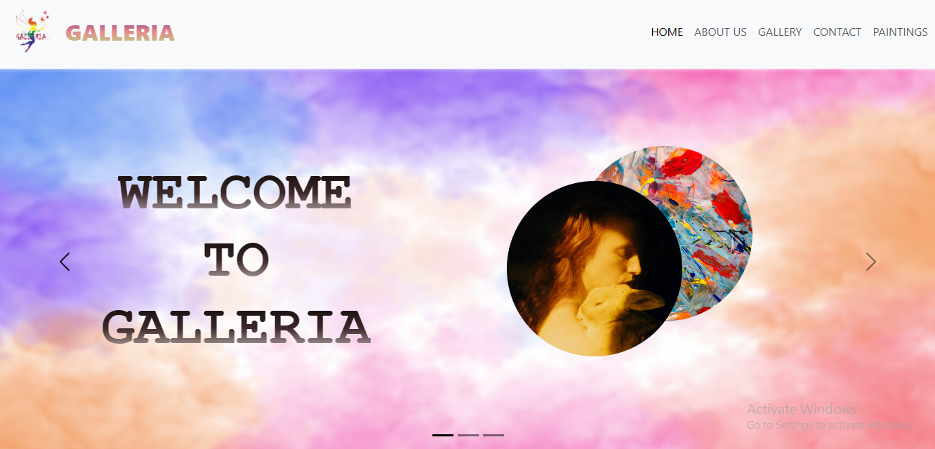

2) **About Us**

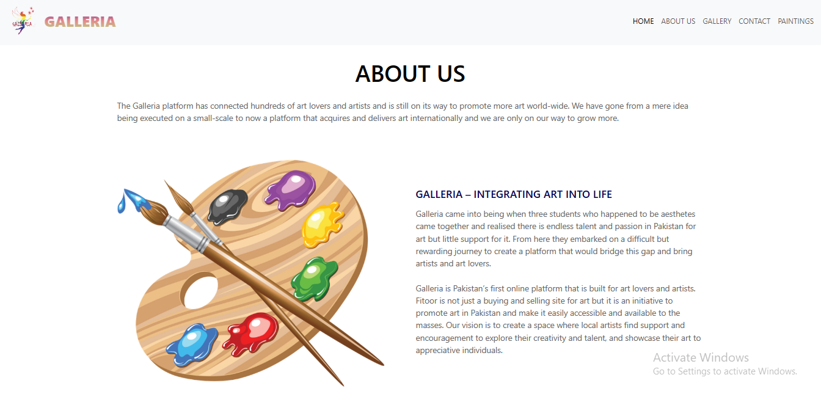

**GALLERY**

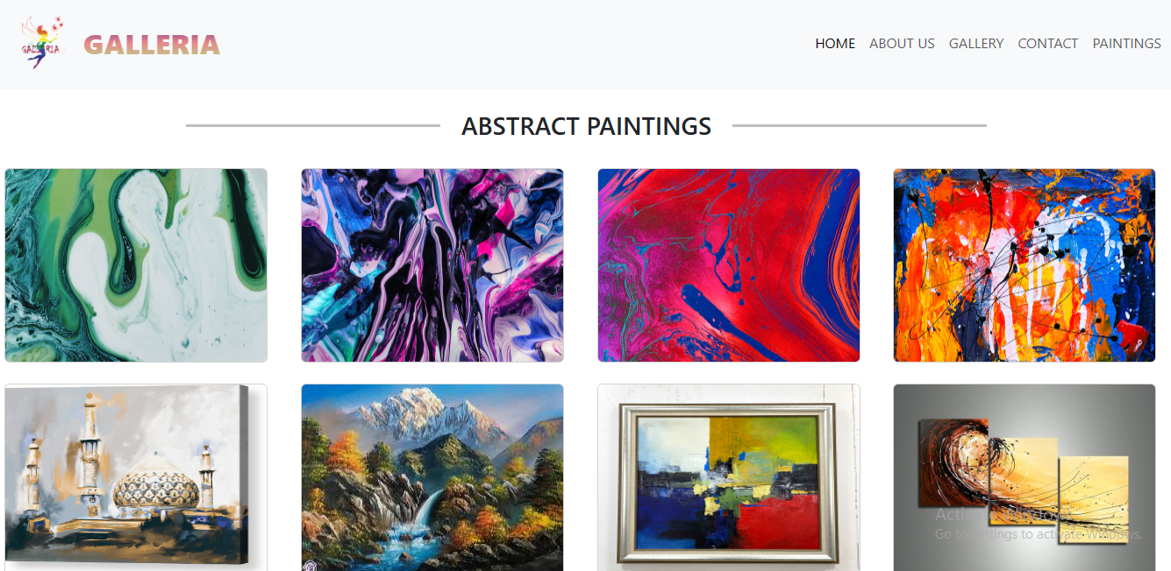

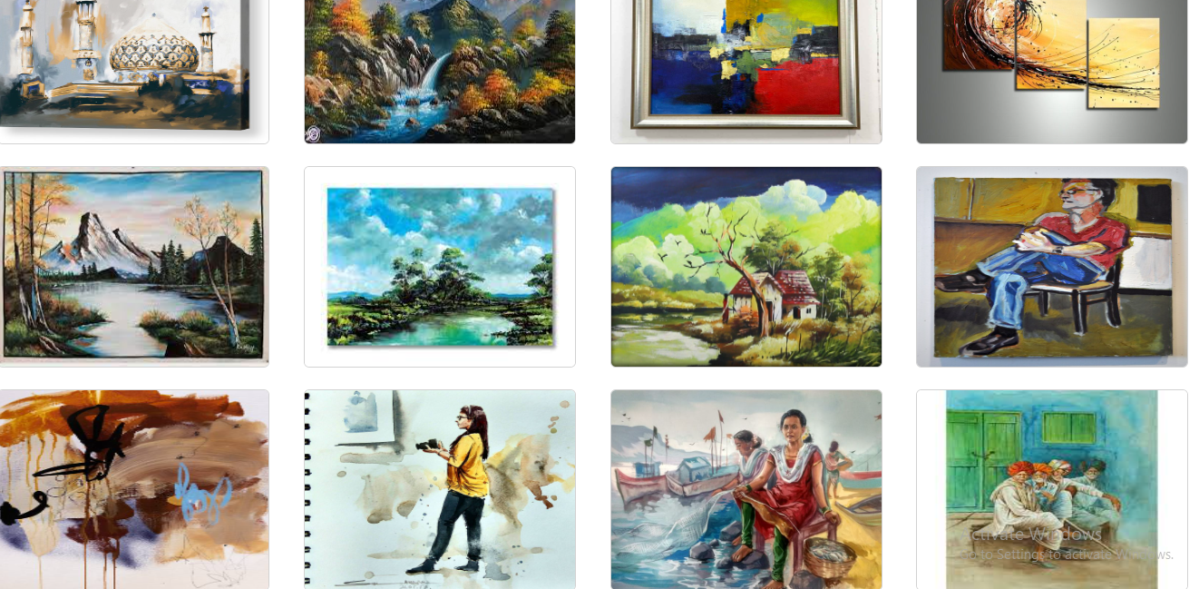

**OTHER CATEGORIES**

**1)ACRYLIC:  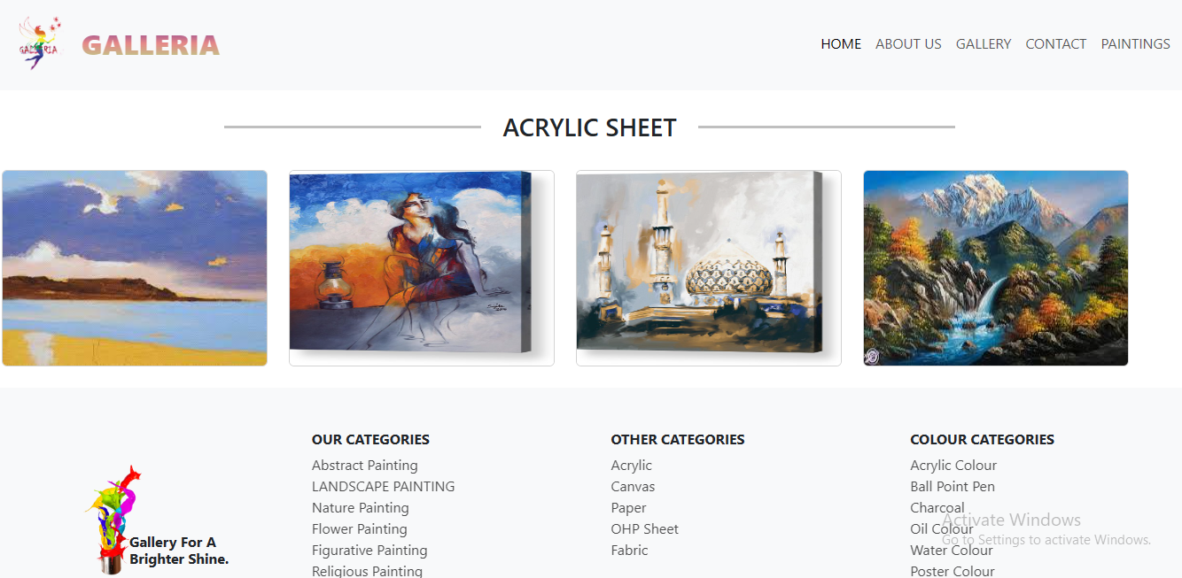**

**2)CANVAS:**

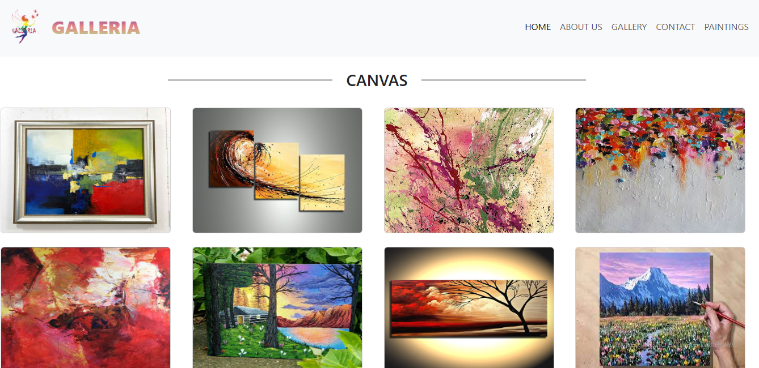

**3)COLOR:**

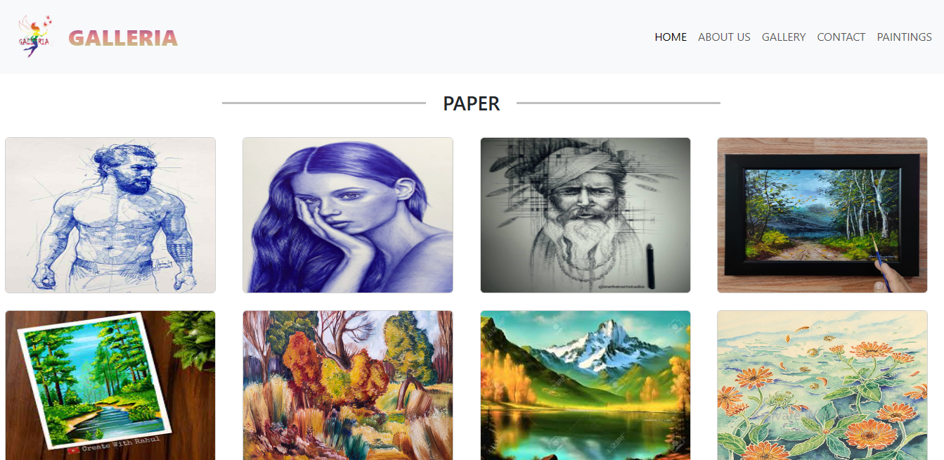

**4)OHP SHEET:**

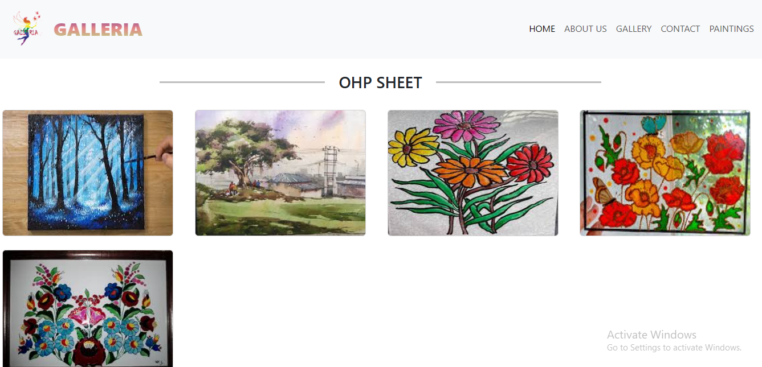

**CONTACT US**

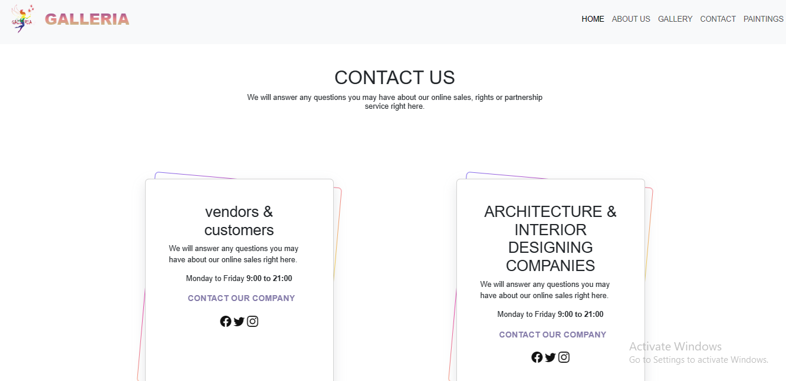

**FAQ’S**

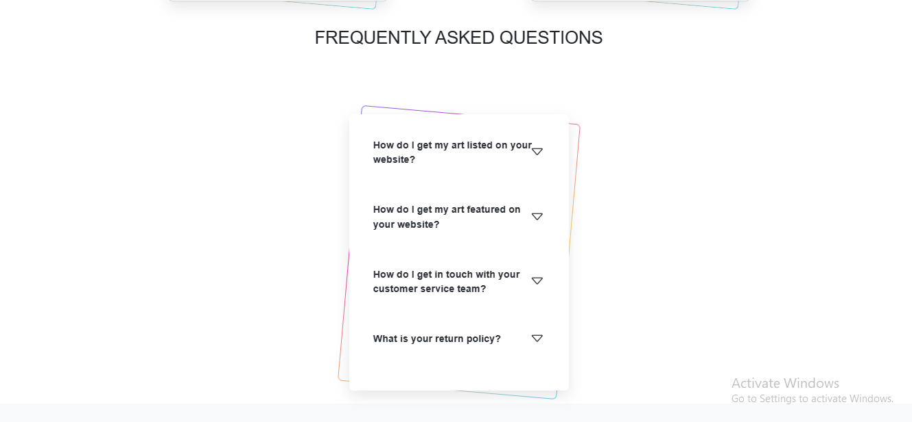

**FOOTER**

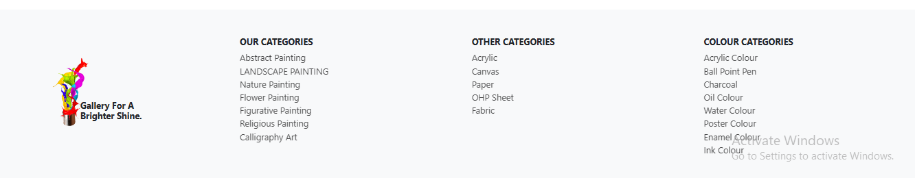

**DEVELOPER’S GUIDE**

**NAVBAR:**

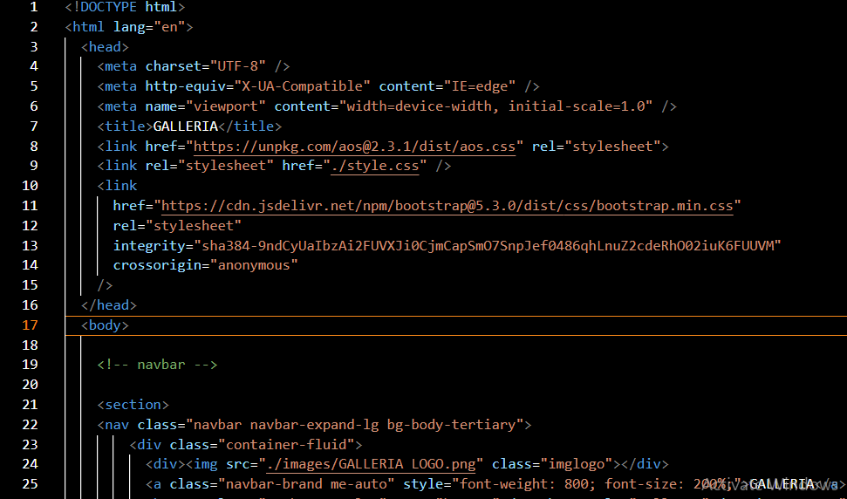

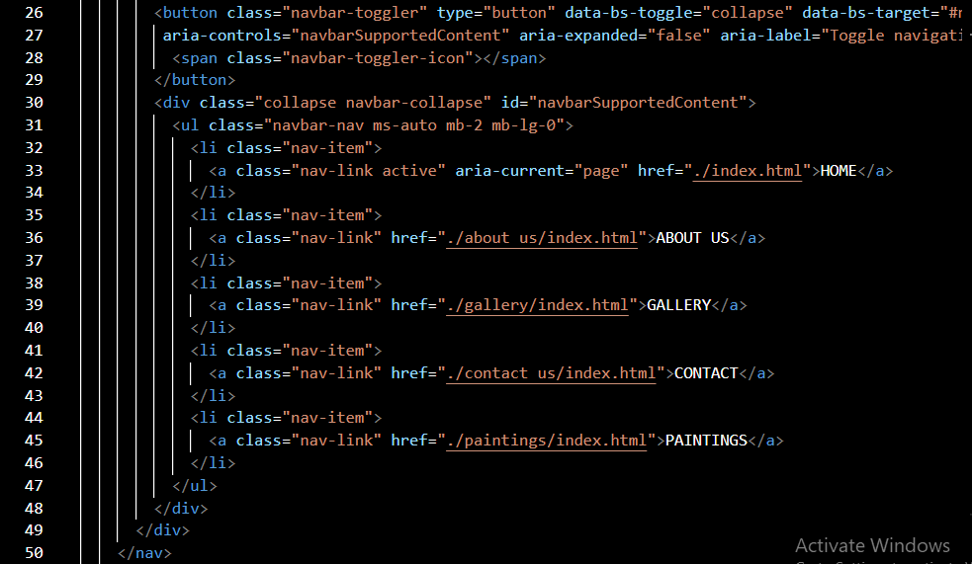

**HOME**

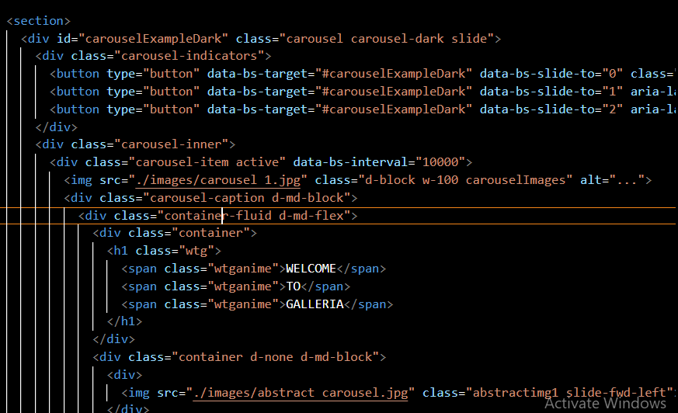

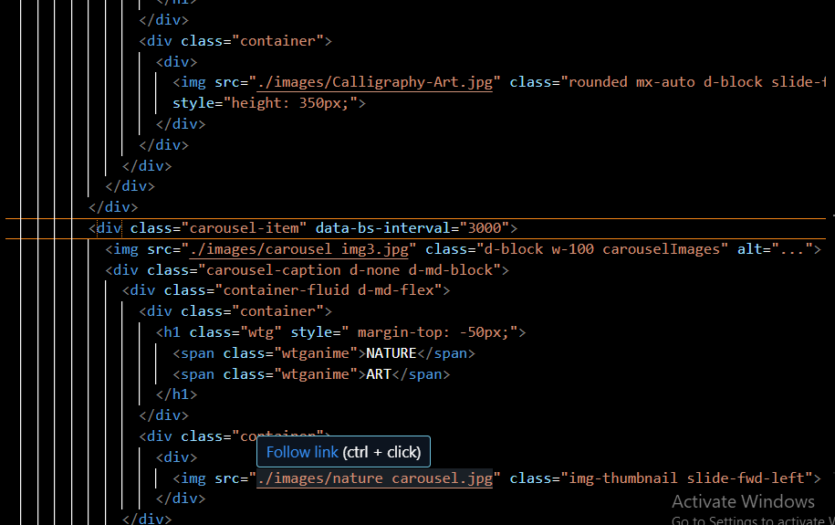

**ABOUT US PAGE**

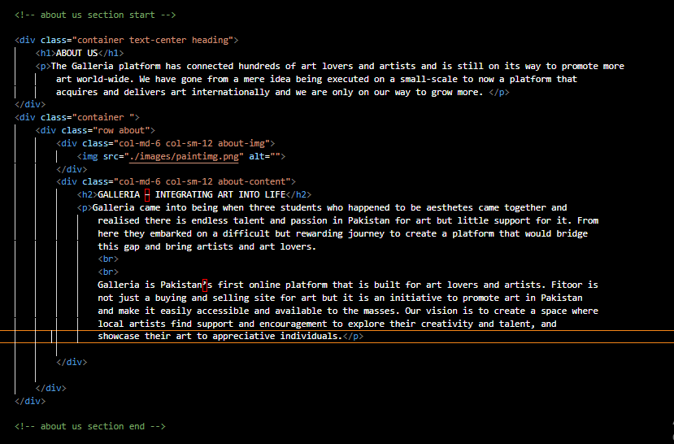

**CONTACT CARD**

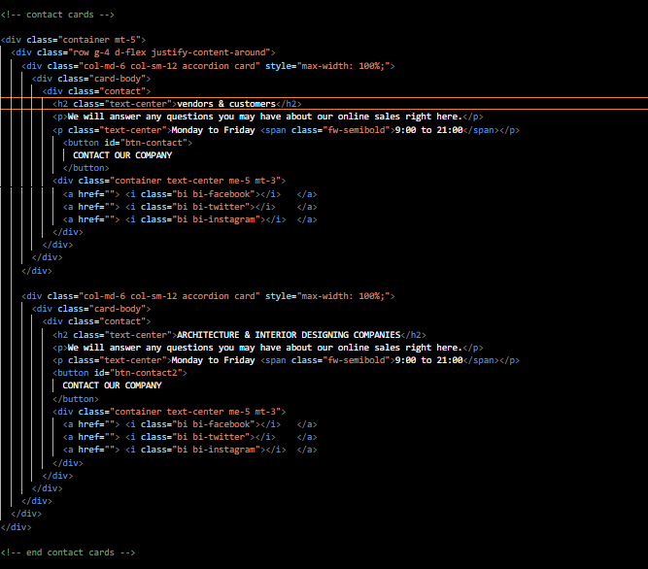

**FAQ’S**

